ADRIAN TURION |  | Avenue de Sainte-Clotilde 9  1205 Geneva, Switzerland | 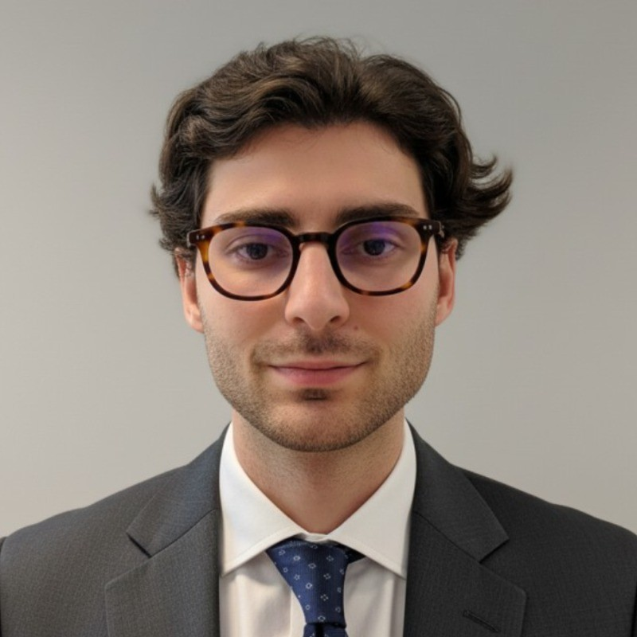
turionadrian@gmail.com | Swiss | 10.11.2000 |  | +41 77 262 37 96
INTRODUCTION
MSc Finance graduate with M&A execution and financial analysis experience in Geneva, combining quantitative rigor with hands-on client exposure across 10+ live mandates. Manages a personal options portfolio with disciplined risk management. Eager to build foundational trading competency at Cargill Ocean Transportation through rotational exposure to freight trading, vessel operations, and analytics.
WORK EXPERIENCE
Auraïa Capital Advisory – Small & Mid Cap Cross-border M&A Boutique  Mergers & Acquisitions Analyst (Converted internship into full-time position) |  | Geneva, Switzerland  Aug 2024 – Current
- End-to-end deal execution in a lean 3-person team: sourcing, valuation, due diligence, negotiations, and closing across 7 live mandates
- Built LBO, DCF, and trading comps models; prepared Board presentations and managed data rooms across multiple concurrent transactions
- Managed relationships with clients, advisors, and counterparties throughout transaction lifecycle on deals valued EUR 5M-50M

RC Group – Currently under LBO with Crédit Mutuel Equity  Mergers & Acquisitions Intern |  | Paris, France  Feb 2024 – Aug 2024
- Worked directly with the CEO of Healthcare and Retail divisions on evaluating acquisition targets in France and Belgium; prepared investment memos with market analysis, competitive positioning, and financial projections; conducted due diligence and built synergy models for targets with revenues EUR 10M-30M

Europ Assistance – Subsidiary of Generali Insurance  Financial Analyst Intern |  | Geneva, Switzerland  Apr 2023 – Aug 2023
- Supported CFO and Head of Controlling on FP&A for the Swiss subsidiary (CHF 50M+ revenues); built automated dashboards in Excel and PowerBI to track KPIs; performed variance analysis on monthly P&L and supported annual budget planning and quarterly forecasting for 5 business units

LEADERSHIP
- McKinsey Case Finalist: Developed predictive model for black swan events using order book data and statistical arbitrage; presented to Keyrock management
- Personal Portfolio Manager: Execute options strategies (Cash Secured Puts, Covered Calls) with disciplined risk management; +8% annualized returns
- Founded Screeny.ai: Built AI-driven buyer identification tool adopted by 3 M&A advisory firms; reduced search time from 10h+ to 20 minutes
EDUCATION
HEC Lausanne  Master of Science in Finance |  | Lausanne, Switzerland  2021 – 2024
- Cumulative GPA: 5.2/6.0 (Top 15% of the class cohort)
- Exchange programs at Waseda University (Tokyo, Japan) and Maastricht University (Maastricht, Netherlands)
- Relevant Coursework: Risk Management, Derivatives, Quantitative Asset and Risk Management, Data Science for Finance
- Thesis Topic: Synergies Analysis of the Merger between American Airlines & US Airways

Bachelor of Science in Management |  | 2018 – 2021
- Cumulative GPA: 4.7/6.0

Scientific Baccalaureate with Highest Honors (16.6/20) |  | Aix-en-Provence, France
ADDITIONAL INFORMATION
Languages:  Computer:  Interests:  References: | French (Native, C2), Spanish (Native, C2), English (Fluent, C1), German (Business proficient, B2-C1)  Financial Modeling | Risk Analysis | Python, SQL, PowerBI | Trading Strategies | Excel (Advanced)  Geopolitics, Badminton (Provence regional finalist), Gym, Real use cases of Artificial Intelligence  Guillaume Arnaldez – Ex-Director at Auraïa Capital Advisory, guillaume.arnaldez@auraia.ch  Sacha Caravatti – CFO at Europ Assistance Switzerland, scaravatti@europ-assistance.ch

